**TranSenses** | Tech Rider - 2015

Naviko [Akiko Kitamura | Navid Navab]

SCHEDULE & SETUP 2 days of setup and rehearsals - TBD with presenter

_______________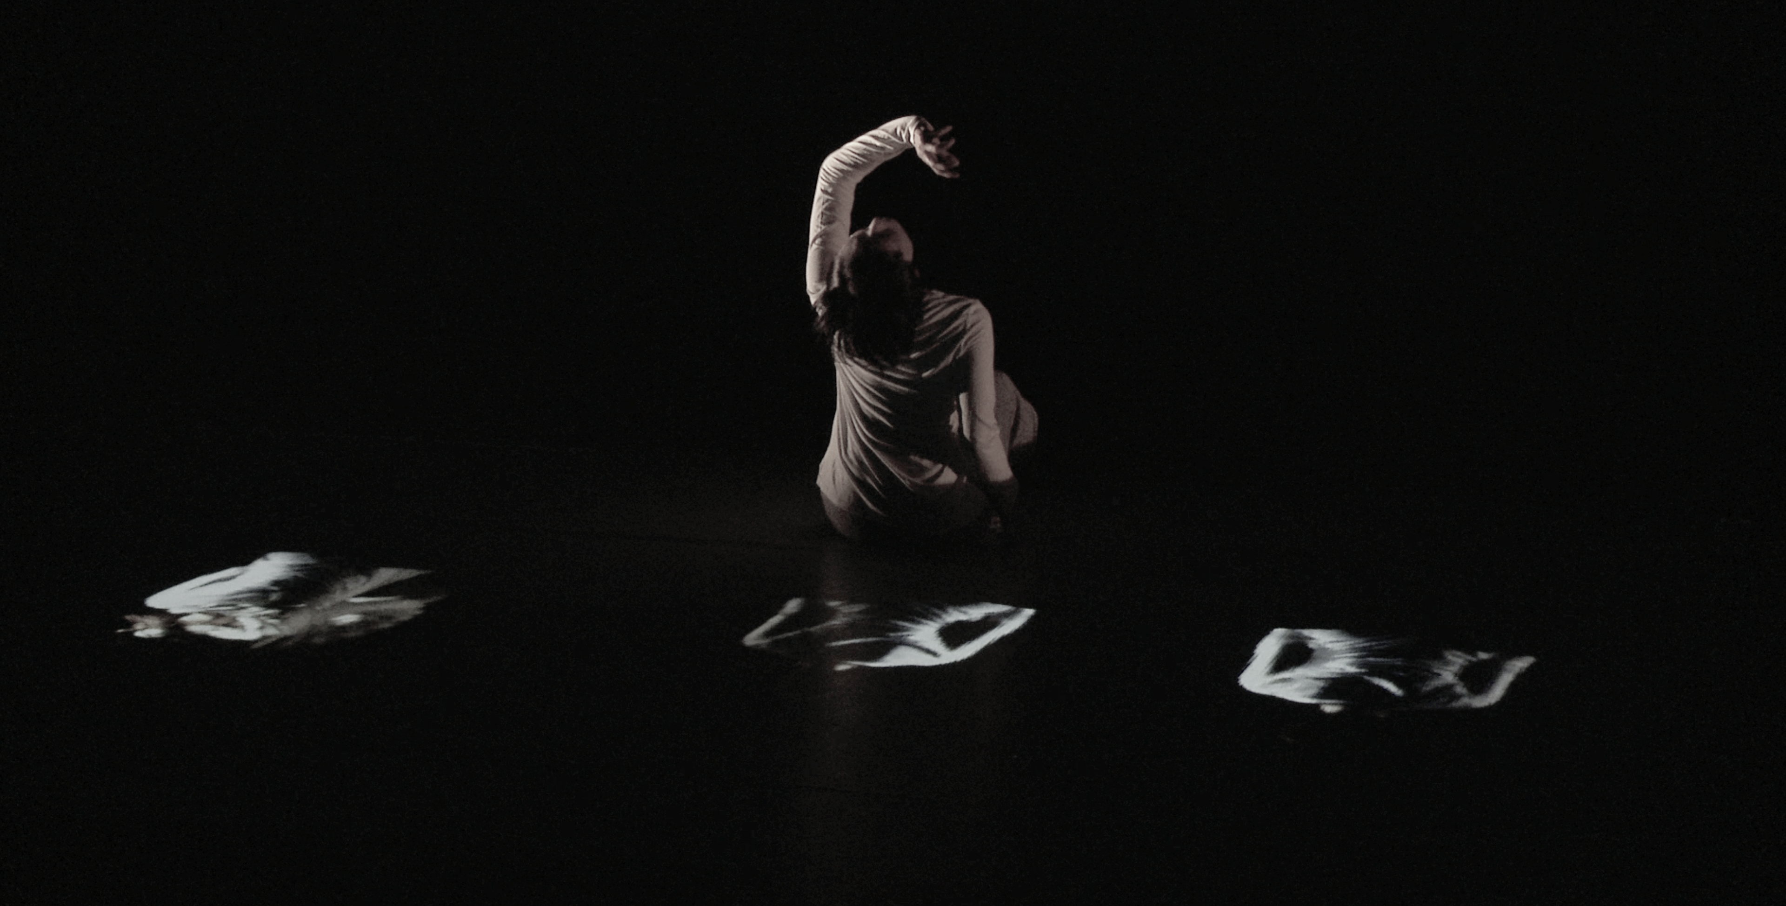__________

|  |  |
| --- | --- |
| SPACE | |
| STAGE SPACE | min. 40’ W x 30’ D  white (or light) dance floor |
| OFFSTAGE SPACE | min 8 feet for side lights |

|  |  |
| --- | --- |
| SETUP | 5 hours minimum (with 3-4 helpers / technicians) |
| AV SOUNDCHECK / CALLIBRATIONS | 3 hours on stage (more is better) |
| REHEARSALS and on-site adaptations | 4 hours |
| PRE-SHOW AV SOUNDCHECK | 1 hour |
| PERFORMANCE | 1 hour |
| STRIKE | 2 hours (with 2-4 helpers / technicians) |

TECHNICAL CONTACT

Navid Navab +1 514 432 6633 [navid.nav@gmail.com](mailto:navid.nav@gmail.com)

_________________________

PROVIDED BY THE PRODUCER

Other Details: Artist will provide two small tracking cameras. one will be rigged to the grid above and the other placed somewhere hidden stage-front.

|  |  |
| --- | --- |
| Setup CREW | 2-3 helpers to help load in, and setup:  1 lighting technician  1 video technician  1 sound technician  NOTE: all crew members are needed for on-site setup and calibration only. The shows are run strictly by the artist only. |
| ELECTRICITY | 2 independent circuits to the tech table (for sound and video gear). |
| ELEMENTS | white or light coloured dance floor |
| AUDIO | Speaker Array (TBD - adapted to venue)   * 2 good subwoofers with a crisp 13-35 Hz response (ie. Meyer Sound) * 8 full range PA Speakers (Meyer UPJ or better) * TRS>XLR cable runs from artist’s interface to the speakers and subs   Other:  2 high res computer screens to connect to our tower computers (DVI/HDMI) |
| VIDEO | * 1 x 10-20k Christie projector or similar, fixed to grid above, pointing down.   HDMI connectivity and extension (ethernet) from projector to the artist machine   * 1 high res computer screen for artist’s computer (we could also bring our own but prefer not to when flying) |
| LIGHTING  PLAN example | 9 x 750-1000 W Lenkos or similar (depends on venue)  4 x 750 watt Fresnel or similar (depends on venue)  4 side lights (three lighting poles on each side of the stage, each supporting two lights)  6 lights rigged as top light  Lighting board offstage by our tech table (TBD) and to be controlled by video artist during the performance |
| REGIE /  AV TECH TABLE | AV Tech table to setup either in the back of the hall or somewhere to the side (depending on the venue). |

PROVIDED BY THE ARTIST

|  |  |  |
| --- | --- | --- |
|  | | value (CAD) |
| COMPUTERS | 1 MacPro 2015  1 MacBook Pro 2014 external hard drive  keyboard, mouse, power supply and other computer accessories  Specialized cables and adaptors | $ 5500  $ 2000  $ 300  $ 900 |
| AUDIO | 2 fader fox midi controllers and midi convertor box  1 rack mount power conditioner  1 RME UFX soundcard  1 RME UCX soundcard  1 Insta snake kit (XLR > ethernet boxes + nuetrik Cat5 cables) | $ 900  $ 400  $ 2500  $ 2100  $ 1000 |
| VIDEO | 1 Point Grey Ethernet Camera with lens and accessories  1 Point Grey Firewire Camera (backup)  2 active firewire 800 cable extenders  Magic Arm (for rigging camera to grid) | $ 1000  $ 500  $ 600  $ 300 |
| SENSORS | 5 X-OSC wireless sensors and accessories  1 wireless router | $ 1000  $ 100 |
| ROAD CASES | 1 x small av rack-gear road case | $400 |

